**Summer Term Sports Clubs**  
**April – May Half Term**

**Mondays**

**3:30 - 4:30: Years 8 & 10 Tennis (OP)**

**3:30 - 4:30: All Years Rounders  
(MLD, CL, HC, BM)**

**3:30 – 4:30: Year 8 Cricket (Astro) (JDK)**

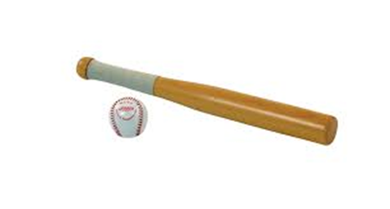

[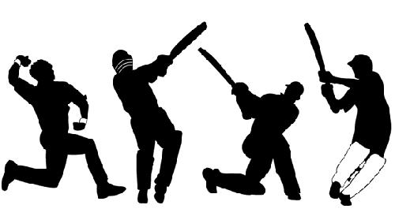](http://www.google.co.uk/url?sa=i&rct=j&q=&esrc=s&frm=1&source=images&cd=&cad=rja&uact=8&ved=0CAcQjRw&url=http://sportyviews.com/cricket-silhouette/&ei=y4sKVdCuDoXkap6PgMAE&bvm=bv.88528373,d.d2s&psig=AFQjCNHA6Ps7_jhRWwxg7stvF-cyVoX1iQ&ust=1426840900250324)

**Tuesdays**

**3:30 - 4:30: Year 7 & 9 Tennis (OP)**

**3:30 – 4:30: Year 7 & 9 Cricket (Astro)**

**(JDK)**

[](http://www.google.co.uk/url?sa=i&rct=j&q=&esrc=s&frm=1&source=images&cd=&cad=rja&uact=8&ved=0ahUKEwiersTD9_rOAhXKtBQKHd7oBP8QjRwIBw&url=http://www.123rf.com/clipart-vector/squash_ball.html&bvm=bv.131783435,d.ZGg&psig=AFQjCNEX5hvcUkLzXzsj_8QHeHsDgY8Kzg&ust=1473257874470393)

**Wednesdays**

**Fixtures – please see separate fixture sheet.**

**Thursdays**

**Lunchtime: Indoor Athletics (BM)**

[](http://www.google.co.uk/url?sa=i&rct=j&q=&esrc=s&frm=1&source=images&cd=&cad=rja&uact=8&ved=0CAcQjRw&url=http://www.ebay.co.uk/itm/Athletes-Running-a-Relay-Race-Athletics-Silhouette-Vinyl-Wall-Art-Sticker-/221272970736&ei=LnnYVIjGE6bT7QbrlYGIBQ&bvm=bv.85464276,d.ZGU&psig=AFQjCNEAkRDHO_ZDqNWWOHgpskKQgG0vvg&ust=1423559336522978)

**Fridays**

**3:30 - 4:15: Cricket Nets (Hard ball) (DW)**

**3:30 – 4:15: Athletics (JMHS P.E Staff)**

For more information about any of the clubs please see a PE member of staff