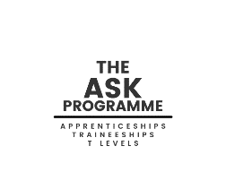
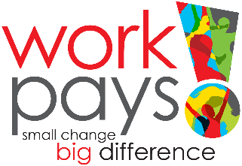
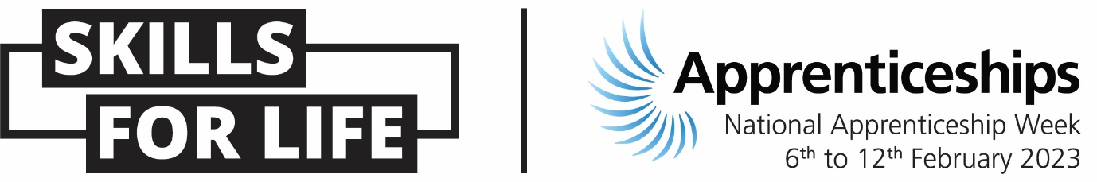
National Apprenticeship Week / ASK Programme
Once again, the ASK Programme are hosting a series of free events during National Apprenticeship Week, please see below for a list of our events and a link to Eventbrite to register. Our events are for students, parents/carers and teachers, feel free to share.
Monday 6th February – Launch Day
9:00 “Welcome to the world of Apprenticeships”
Eventbrite link - https://www.eventbrite.co.uk/e/welcome-to-the-world-of-apprenticeships-9am-tickets-484389651487
13:00 “Welcome to the World of Apprenticeships”
Eventbrite Link – https://www.eventbrite.co.uk/e/welcome-to-the-world-of-apprenticeships-1pm-tickets-482389157957
16:30 “Welcome to the World of Apprenticeships”
Eventbrite Link - https://www.eventbrite.co.uk/e/welcome-to-the-world-of-apprenticeships-1630pm-tickets-482331956867
18:00 “Welcome to the World of Apprenticeships”
Eventbrite link - https://www.eventbrite.co.uk/e/welcome-to-the-world-of-apprenticeships-6pm-tickets-482974157707
19:00 “Welcome to the World of Apprenticeships”
Eventbrite link - https://www.eventbrite.co.uk/e/welcome-to-the-world-of-apprenticeships-1900-tickets-483798423107
Tuesday 7th February – Employers
11:00 “Meet the Employer – Derby Homes”
Eventbrite Link - https://www.eventbrite.co.uk/e/meet-the-employer-derby-homes-11am-tickets-516815658547
15:00 “Meet the Employer- Finning CAT”
Eventbrite link- https://www.eventbrite.co.uk/e/meet-the-employer-finning-cat-3pm-tickets-507601348297
16:00 “Meet the Employer Unilever”
Eventbrite link - https://www.eventbrite.co.uk/e/the-unilever-apprenticeship-program-tickets-515036015587
18:00 “Meet the Employer - Coventry Council Apprenticeships”
Eventbrite link- https://www.eventbrite.co.uk/e/meet-the-employer-coventry-council-apprenticeships-6pm-tickets-489662743447
18:00 “Apprenticeships with West Midlands Police PC David Manns & PC Amy Davies”
Eventbrite link- https://www.eventbrite.co.uk/e/apprenticeships-with-west-midlands-police-pc-david-manns-pc-amy-davies-registration-507575270297
18:00 “Apprenticeships with Doc Martens”
Eventbrite link - https://www.eventbrite.co.uk/e/meet-the-employer-doc-martens-tickets-507542371897

Wednesday 8th February – Apprentices
13:00 “Being a Fragrance Supply Lead at Boots with Alice Pett”
Eventbrite link- https://www.eventbrite.co.uk/e/being-a-fragrance-supply-lead-at-boots-with-alice-pett-registration-511497732487
16:30 “Meet the Apprentice from Finn Cat”
https://www.eventbrite.co.uk/e/meet-the-apprentice-from-finn-cat-engineering-430pm-tickets-511818211047

17:00 “Meet the Apprentice from Doc Martens
Eventbrite Link - https://www.eventbrite.co.uk/e/meet-the-apprentice-doc-martens-tickets-507602060427
17:30 “Meet the Apprentice – Digital Marketing with John Francis”
Eventbrite link- https://www.eventbrite.co.uk/e/meet-the-apprentice-digital-marketing-with-john-francis-tickets-510508202777
18:00 “Food for thought! Talking about Apprenticeships with Mondelez International”
Eventbrite link- https://www.eventbrite.co.uk/e/food-for-thought-talking-about-apprenticeships-with-mondelez-international-registration-514822075687

Thursday 9th February – T Levels
12:00 “Welcome to the world of T Levels”
Eventbrite link - https://www.eventbrite.co.uk/e/welcome-to-the-world-of-t-levels-tickets-483711242347
13:00 “Welcome to the world of T Levels”
Eventbrite link - https://www.eventbrite.co.uk/e/learn-all-about-t-levels-1pm-tickets-482986655087
18:00 “Welcome to the world of T Levels”
Eventbrite link - https://www.eventbrite.co.uk/e/welcome-to-the-world-of-t-levels-6pm-tickets-484399340467

Friday 10th February – Celebrations
14:00 “Celebration of Apprentices- Christa Bridges’ journey with PebblePad”
Eventbrite link- https://www.eventbrite.co.uk/e/celebration-of-apprentices-christa-bridges-journey-with-pebblepad-2pm-tickets-506440596457

Saturday 11th February – Parents/Carers Day
9:30 “A Parents & Carers Guide to understanding Apprenticeships”
Eventbrite link - https://www.eventbrite.co.uk/e/helping-parents-carers-understand-the-apprenticeship-pathway-tickets-483253061917
10:30 “A Parents & Carers Guide to understanding Apprenticeships”
Eventbrite link – https://www.eventbrite.co.uk/e/a-parent-carers-guide-to-understanding-apprenticeships-tickets-482516739557
11:30 “A Parents & Carers Guide to understanding Apprenticeships”
Eventbrite link - https://www.eventbrite.co.uk/e/a-parent-carers-guide-to-understanding-apprenticeships-tickets-483291707507

