Bridging the gap to A-Level Further Maths

# Number

1. Which of the following are integers?

3 -2.8 0.4 3

4

7.92 -9 202 0

1. Which of the following values are rational and which are irrational?

.

4.7 π √8 1

5

-7 √16 12.452 3.1

1. If 0 < 𝑥 < 1, compare the size of 𝑥 − 1 𝑡𝑜 𝑥2 − 𝑥

𝑥

# Indices, expanding and factorising

1. If 22𝑥+1 × 4𝑥+1 = 8𝑥+2, find the value of 𝑥
2. Factorise the following:

5𝑦(𝑦 − 1) + 3(𝑦 − 1) 𝑝𝑞2 − 𝑝2𝑞 16𝑚2 − 81𝑛2

1. Multiply out the brackets and simplify where possible:

(𝑥 − 2)(2𝑥 + 3)(𝑥 + 7) − (𝑥 − 3)(𝑥 − 1)(3𝑥 + 2) (𝑥 + 1)(𝑥 − 1)(𝑥 + 5)(4𝑥 − 1)

7) (𝑥 − 3)(2𝑥 + 1)(𝐴𝑥 + 1) ≡ 8𝑥3 + 𝐵𝑥2 + 𝐶𝑥 − 3 Work out the value of A, the value of B and the value of C.

# Inequalities

8) Solve the following:

8𝑥 + 3 ≤ 4𝑥 3(4 − 𝑥) > 3 3𝑥2 + 2 < 14

7𝑥2 − 4 ≥ 59 𝑥2 − 4𝑥 + 10 ≥ 2𝑥 + 5

9). Draw a set of axes, show the region that satisfies the following inequalities:

𝑦 > 3𝑥 − 2 𝑦 < 𝑥 + 2 𝑦 + 𝑥 > −1

# Functions and Proof

10) 𝑓(𝑥) = 𝑥+5

3

and 𝑔(𝑥) = 𝑥 − 3

Evaluate 𝑓(4) Find 𝑓𝑔(𝑥) Find 𝑓−1(𝑥)

11). 𝑓(𝑥) = 3𝑥3 − 2𝑥2 + 4 Express 𝑓(𝑥 + 2) in the form 𝑎𝑥3 + 𝑏𝑥2 + 𝑐𝑥 + 𝑑

1. a) Express 𝑥2 + 6x + 11 in the form (𝑥 + 𝑎)2 + b where a and b are integers

b) Hence, prove that 𝑥2 + 6x + 11 is always positive

# Drawing graphs and transformations of curves

1. A curve has the equation 𝑦 = 2𝑥2 − 5𝑥 + 12
   1. Write the curve in the for y = 𝑎 (𝑥 + 𝑚)2 + 𝑛 and hence find the minimum points of the graph.
   2. Does the graph cross the x-axis? If yes, find the coordinates of the point of intersection.
2. On separate axes, sketch the following graphs:
   1. 𝑦 = −𝑥3 𝑏) 𝑦 = −3 c) 𝑦 = 1 + 1 d) 𝑦 = 2

𝑥 𝑥

𝑥2

1. The graph of 𝑦 = sin(𝑥) is plotted below. Sketch the following transformations of

𝑦 = sin(𝑥)on the same set of axes:

* 1. 𝑦 = 2 sin(𝑥)
  2. 𝑦 = sin(4𝑥)
  3. 𝑦 = sin(𝑥 − 90)

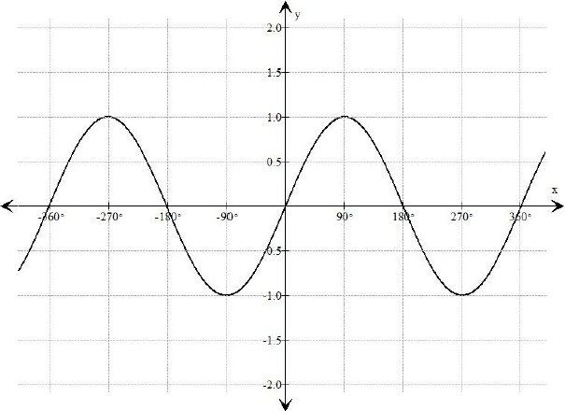

1. The diagram shows part of the curve with equation 𝑦 = 𝑓(𝑥). The coordinates of the minimum point of this cuvre are (3, 1).

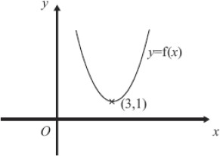

Write down the coordinates of the minimum point of the curve with equation:

* 1. 𝑦 = 𝑓(𝑥) + 3
  2. 𝑦 = 𝑓(𝑥 − 2)
  3. 𝑦 = 𝑓 (

1

2

𝑥)

# 3D Trigonometry and Pythagoras’ Theorem

1. A cuboid has dimensions 2*n*, *n* and *n*  1 cm. A diagonal has length 2*n* + 1 cm.

Not drawn accurately

*n*  1

*n*

2*n* + 1

2*n*

Work out *n*.

1. A hanging basket is made from a hemisphere and three chains. The radius of the hemisphere is 10 cm.

Each chain is 30 cm long.

The chains are equally spaced around the rim of the hemisphere.

Work out angle *AOB*.

*O*

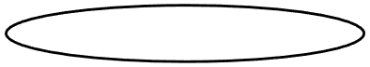

*A*

*B*

# Sequences

4 cm 5 cm 6 cm

3 cm

4 cm

5 cm

This pattern of rectangles continues.

Show that the sequence of numbers formed by the areas of these rectangles has *n*th term

*n*2 + 5*n* + 6

A linear sequence starts

|  |  |  |  |  |
| --- | --- | --- | --- | --- |
| *a* + *b* | *a* + 3*b* | *a* + 5*b* | *a* + 7*b* | ………….. |

The 5th and 8th terms have values 35 and 59.

1. Work out *a* and *b*.
2. Work out the *n*th term of the sequence.

# Transformations and Loci

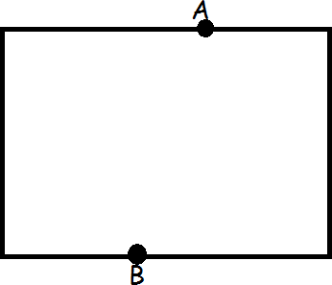A snail moves so that it is always within the rectangle and is equidistant from points A and B. Use ruler and compasses to show where the snail moves.

1. In this order, perform the following two transformations to shape F.
   1. Rotation 180° clockwise about (1,2)
   2. Reflection in the line 𝑦 = 𝑥

Mark the resulting shape with a G. Extension: Are there any invariant points?

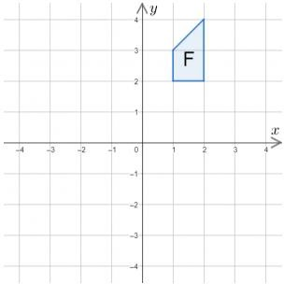

Fully describe the single transformation from the triangle ABC to its image.

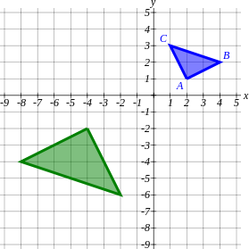

# Vectors

*B*



*A*

6**a**

*P*

Diagram **NOT**

accurately drawn

*O* 6**c** *C*

*OABC* is a parallelogram.

*P* is the point on *AC* such that *AP* =

2 *AC*.

3

*OA* = 6**a.** *OC* = 6**c.**

1. Find the vector *OP* .

Give your answer in terms of **a** and **c**.

The midpoint of *CB* is *M***.**

1. Prove that *OPM* is a straight line